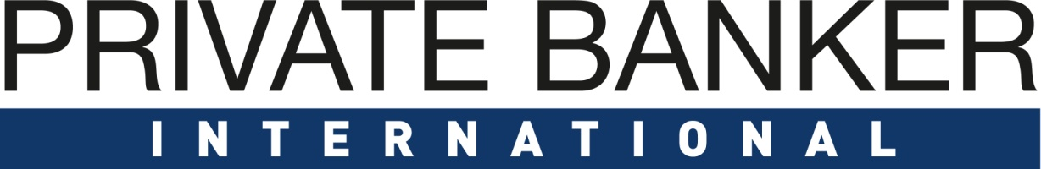

Private Banking: Switzerland Awards 2019

Entry Form

PART A – must be received by 30.10.2019
Company Details
Company Name
Company Address (including Postcode)
Contact Person
Contact Details
Submission Details
Item | Details
Tick Submission Award Categories | Outstanding Customer Relationship Service and Engagement in Switzerland
 | Excellence in Customer Experience (Technology Provider)
 | Best Next Generation Offering in Switzerland
 | Outstanding UHNW Offering in Switzerland
 | Outstanding Philanthropy Proposition in Switzerland
 | Outstanding Family Office Proposition in Switzerland
 | Outstanding Wealth Management Technology Provider in Switzerland - Middle and Back Office (Vendor)
 | Outstanding Wealth Management Technology Platform in Switzerland (Bank)
 | Outstanding Front-End Digital Solutions Provider (Vendor)
 | Outstanding Boutique Private Bank in Switzerland
 | Outstanding Private Bank – Switzerland - International Players
 | Outstanding Private Bank – Switzerland- Domestic Players
 | Most Innovative Private Bank / Wealth Manager of the Year
 | The Diversity Award
Declaration  I have read the information in the notes below and as provided in the Awards Information Pack. I am submitting this entry in accordance with those instructions. I guarantee that the information provided is true and correct at the point of submitting this entry.  Notes: For Additional Details please refer to the information pack  - The deadline for completed and signed entries is 30.10.19 Please ensure your form has been emailed to events@arena-international.com  - Please fill one form for each category entered. |  | ………………………………….  Authorised Signatory
PART B – must be received by 30.10.2019
Award Snapshot
(Please describe in between 500 – 1000 words or less why your programme or product should be nominated in this category. Please refer to the bullet points below the category when outlining your rationale.) Graphs and pictures can be copied into this document.

Website URL
Any other details you wish to share

There are several general and social media sponsorship options available if you would like to sponsor an award, a category or social media interactions. Please get in touch with Ray Giddings- ray.giddings@arena-international.com for further information. Please send this form & any supporting documents to events@arena-international.com by 30.10.2019

